I am investigating which squash scoring system, Point-a-rally or English scoring, is better. To determine the better system, I will take factors such as player advantage and skill into account.

Personally, I am expecting the initial server in an English game to have a higher chance of winning a game for a particular value of ra/rb verses PARS. This is because the opponent must win 2 rallies in a row to get one point unlike PARS. Using pars, in my simulation, the server should have no increased odds of winning.

Each player has a skill level (1 - 100) which can be used to calculate the chance of them winning a point.

To show how these systems, differ, I will perform 2 main simulations. Firstly, a simulation which takes a large range of ra/rb (100 values) and compares the probability that player A wins for each value. Rb shall remain constant (at 50) and ra shall range from 1 to 100. The probability will be calculated by running many games for each ra/rb value and getting the average chance of victory for a. Then, the probability will be plotted against ra/rb on a graph for both PARS and English games.

To implement this, I will have to create an English game function and a function to call it simulation times and return the average probability for a. Ra and rb will be given as parameters along with the number of simulations. The server will be given as a parameter.

Secondly, I am going to do another similar simulation except that this time ra/rb remains constant. This is to compare whether a particular player has a win advantage even if skill levels are equal. The same functions will be used, but now it will be plotted using a box plot.

During these simulations, we are assuming that a player does not get tired during a game, thus their skill or ability to successfully win a rally stays constant throughout a match. We are also assuming that no external/environmental factors effect a player’s skill. E.g. pressure of winning could increase their likelihood of making a misplay. And that one player does not perform better as a server.

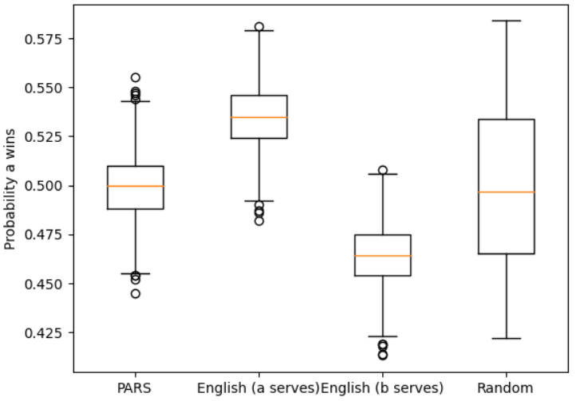

From this graph we can determine a few things. Firstly, PARS produces an almost equal distribution around 0.5 (50%). Suggesting that each player has an equal chance of winning the game.

In the second and third plot, we can see that the initial server effects the probability of A winning. Therefore, we can deduce that the initial server has a slightly higher chance of winning a game. The fourth plot has a much larger spread showing how much a game can vary purely on who plays first.

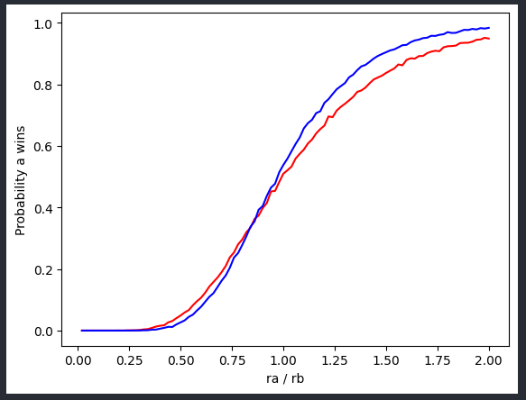

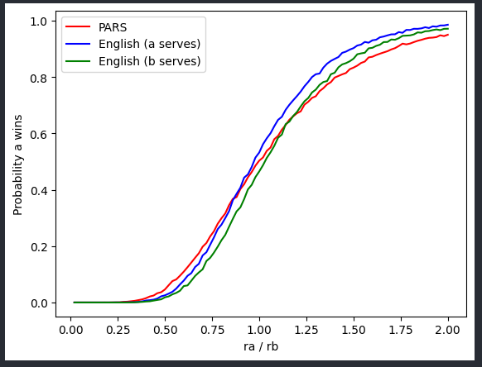This graph further supports the theory as a clearly has a higher chance of winning than b for the majority of ra/rb when serving. However, it also shows that for low values of ra/rb being the initial server has a lower chance of winning than in PARS. This is most likely due to the fact that once the opponent becomes the server, their skill level outweighs the impact of initially serving and they have a higher chance of continuing than the opponent winning twice in a row. This is even more noticeable when b serves as it takes a higher level of ra/rb for the probability to exceed the pars game.

In conclusion, I believe that PARS is the better squash scoring system. This is because in English scoring, the initial server has an increase in their chances of winning at an equal or higher skill level. And at a lower skill level their chances of winning are reduced regardless, but more noticeably when they are not the server. In my opinion a player should not have an advantage based on initial starting conditions and should only have an advantage based on their own skill. Even if the server is determined randomly, it is still possible that one player ends up starting first multiple times just due to random chance. In the future I would also like to test factors such as game length to improve my decision as the difference in win rate is not as much as expected. Additionally testing equal skill levels causes very long game times, and thus takes much longer to calculate, I would use different skill levels in future projects. My system was also limited by the range of ra/rb values. Thus, I would also increase the amount of values.